Name : Mriganka Patra

Emp id: 2415820

Email : mriganka.patra@cognizant.com

Day 10

Assignment 2:

Salesforce – Service Cloud and Additional Platform Features

Objective:

Explore Service Cloud capabilities and additional Salesforce platform tool lke Chatter, Activities, App Launcher, and App Exchange

Tasks:

1. Set up Service Cloud and create a simple Case Management system:

* Create Case Record Type and configure assignment rules
* Automate Case escalation based on Priority

1. Use Chatter to:

* Collaborate on Case and an Opportunity
* Mention users and follow records

1. Track Activities on a Lead and a Case:

* Log calls, emails and meetings

1. Use App Launcher to navigate between Sales, Service, and Custom Apps
2. Visit App Exchange and install a free app(or document how to find and evaluate apps).

Deliverables:

* Case setups and automation details
* Chatter activity examples
* Logged activities and App Launcher exploration
* Summary on AppExchange app evaluation or installation

Task 1: Set up Service Cloud and create a simple Case Management system:

* Create Case Record Type and configure assignment rules
* Automate Case escalation based on Priority

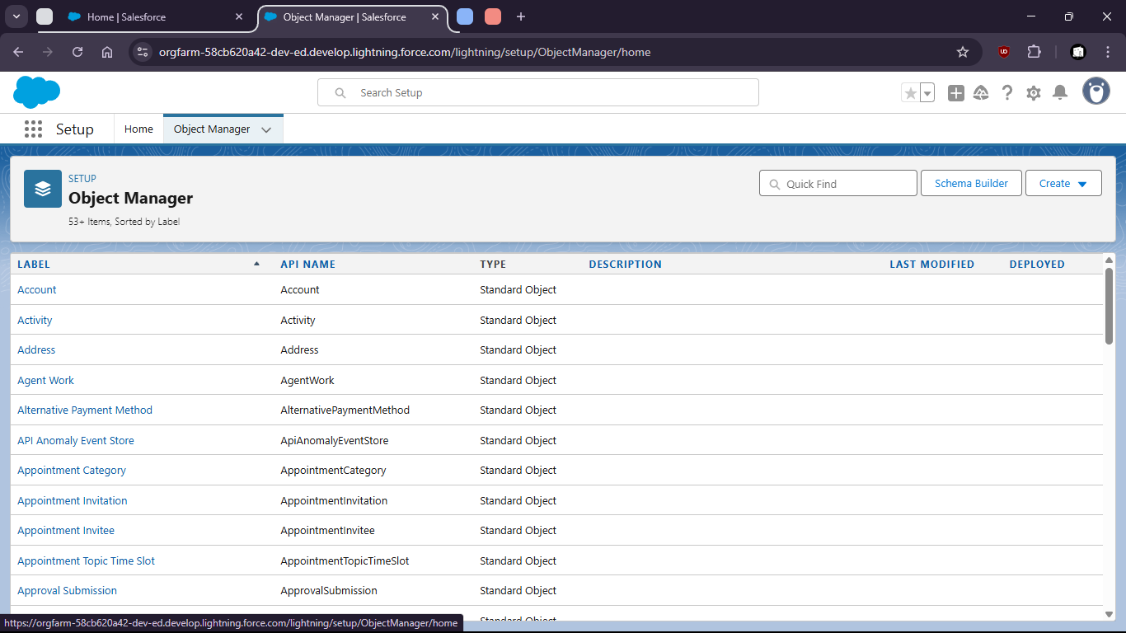

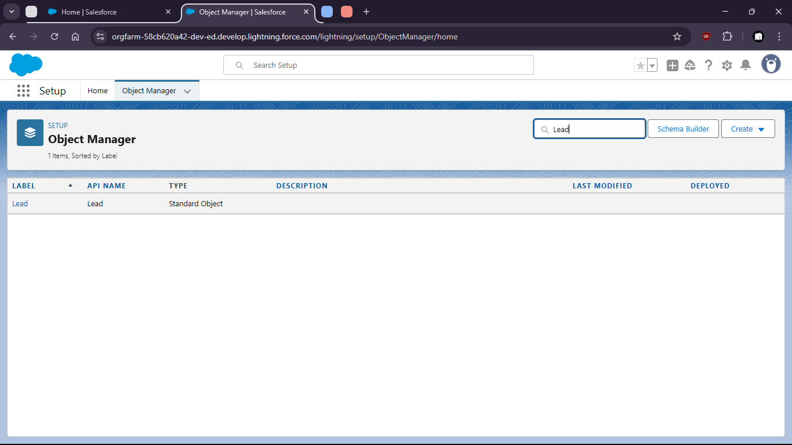

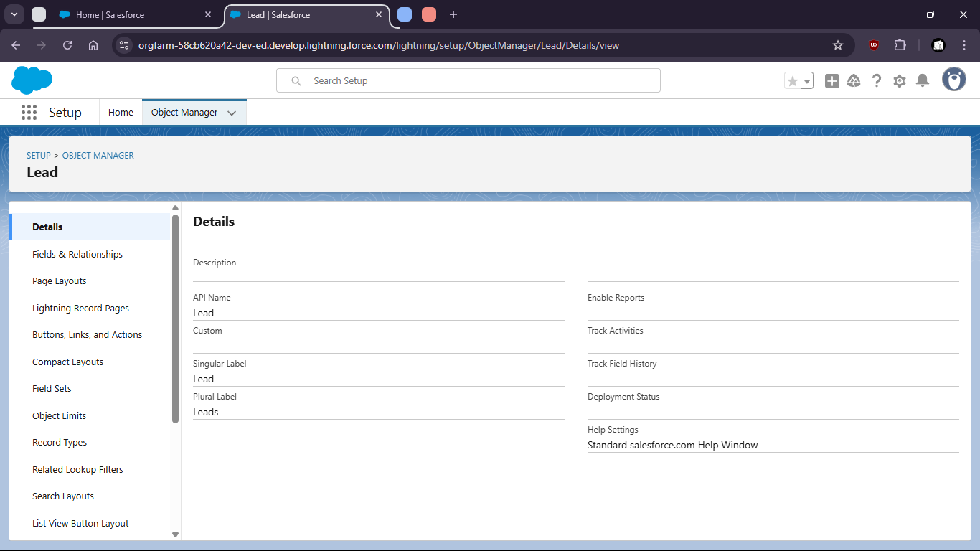

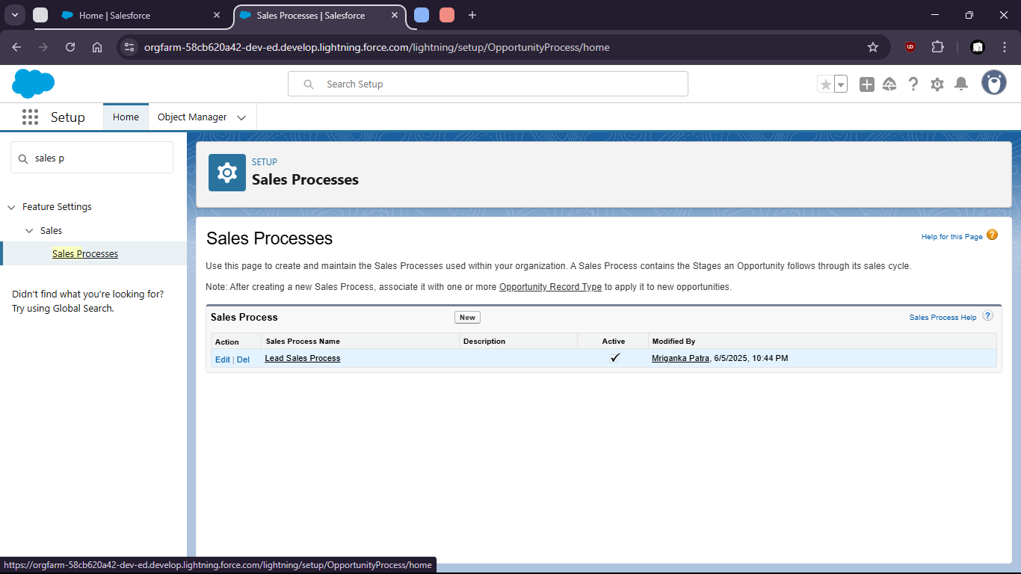

Automate case escalation based on Priority

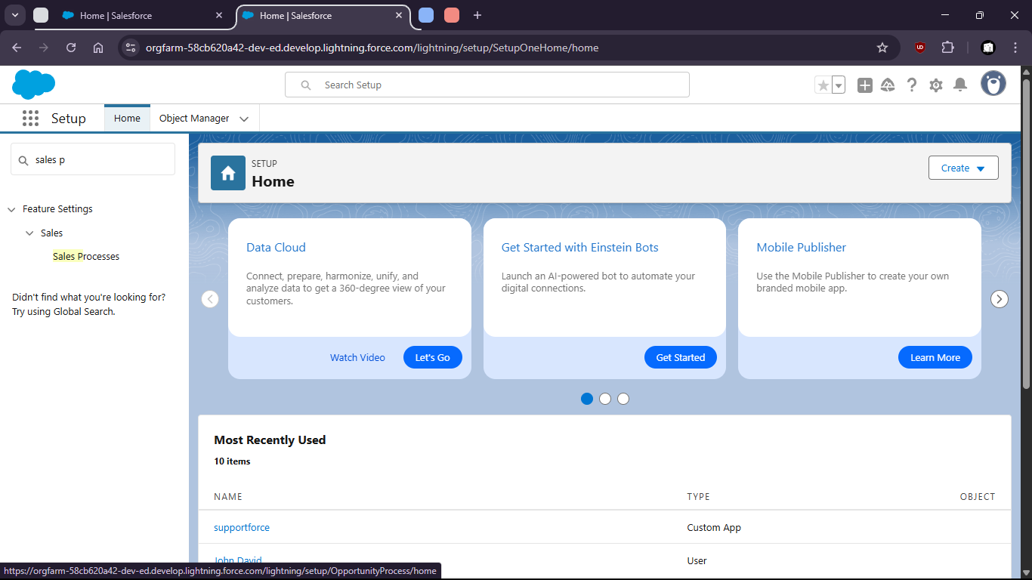

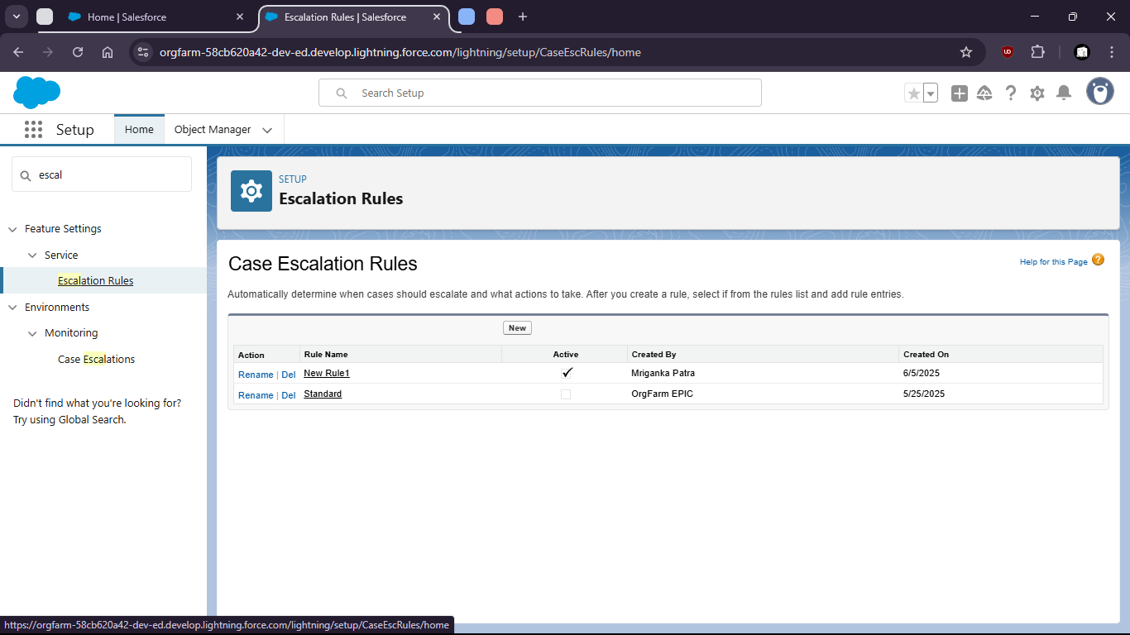

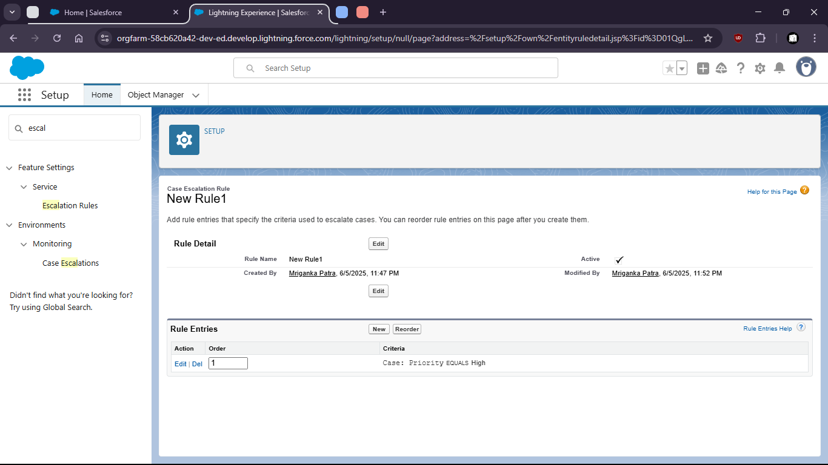

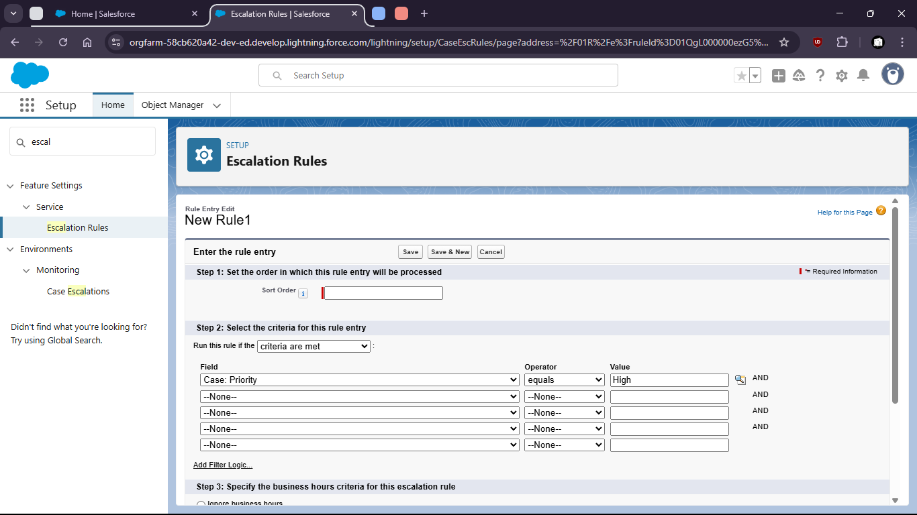

Task 2: Use Chatter to:

* Collaborate on Case and an Opportunity

- Mention users and follow records

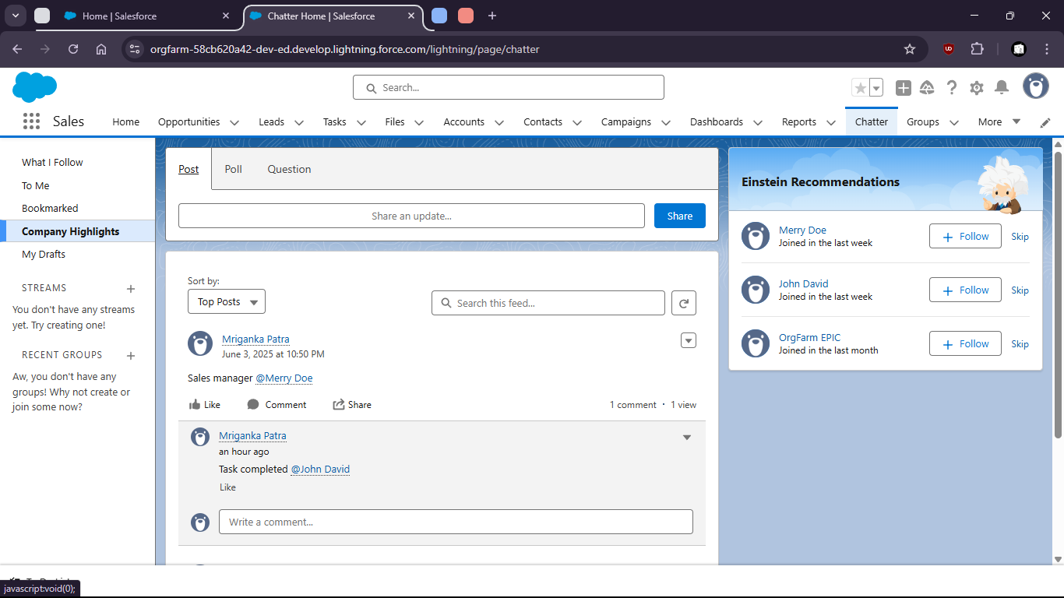

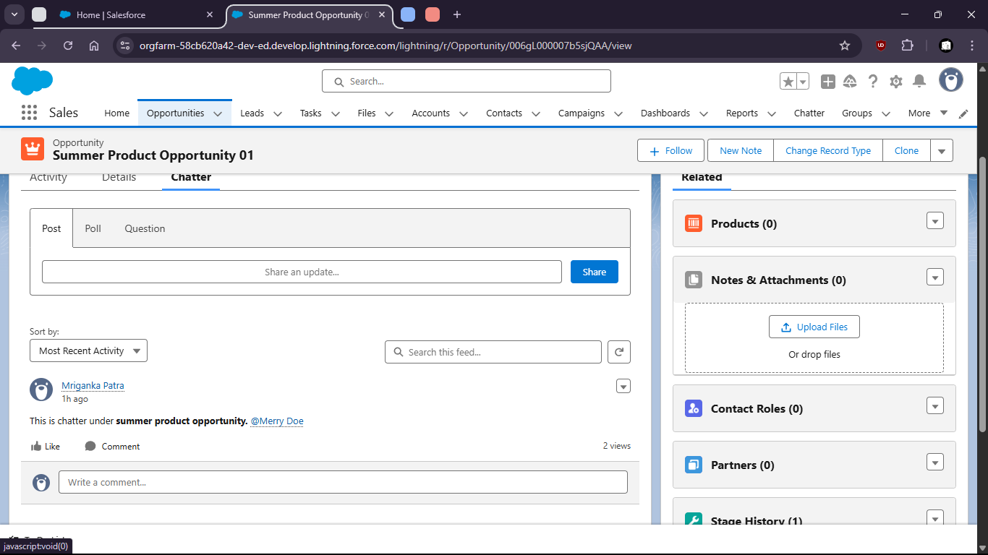

Task 3:

- Track Activities on a Lead and a Case:

* Log calls, emails and meetings

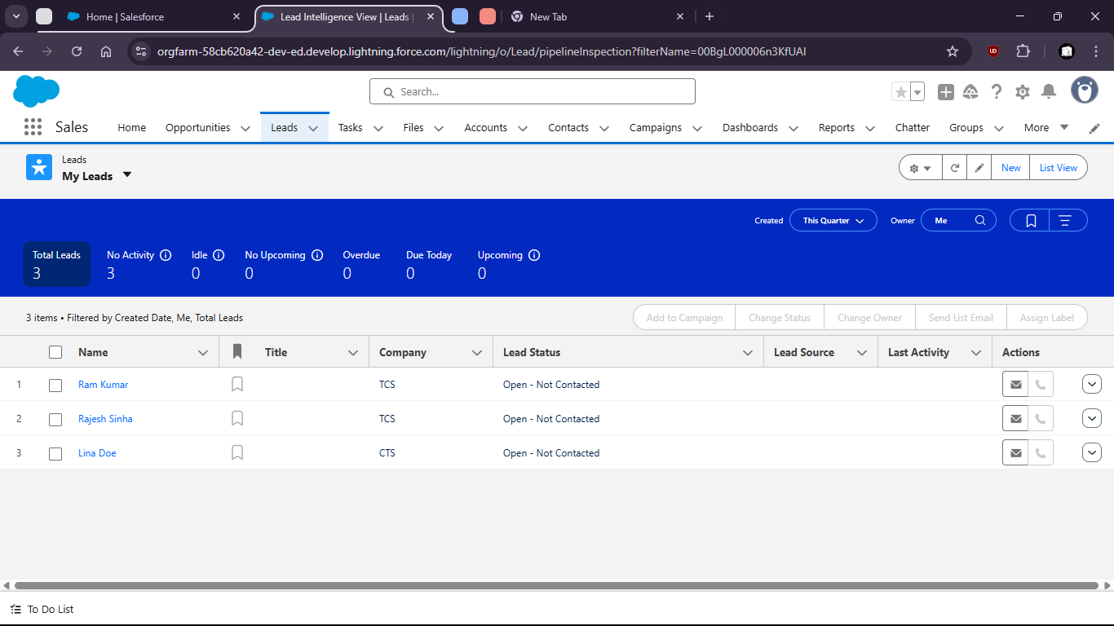

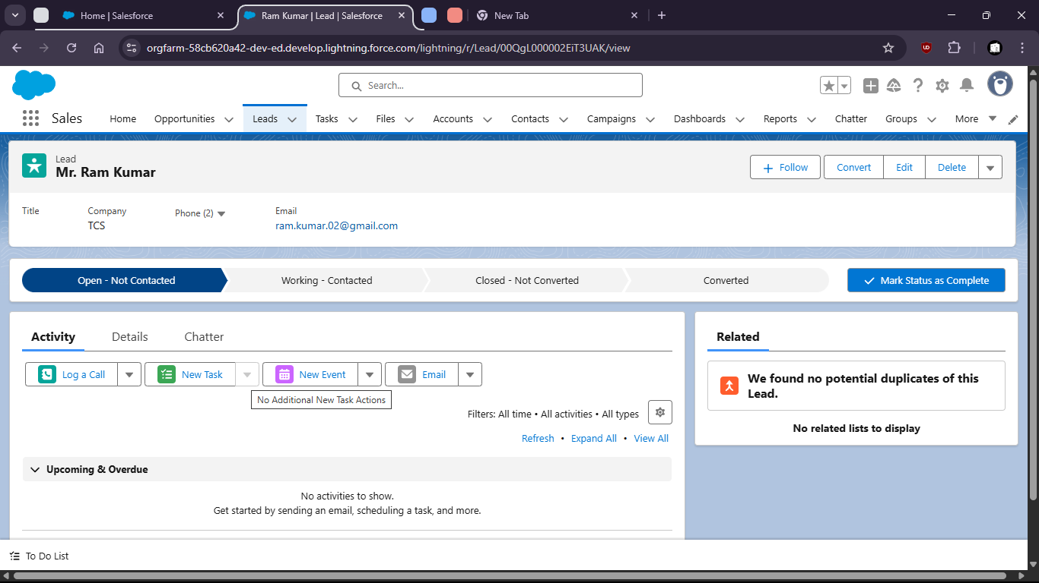

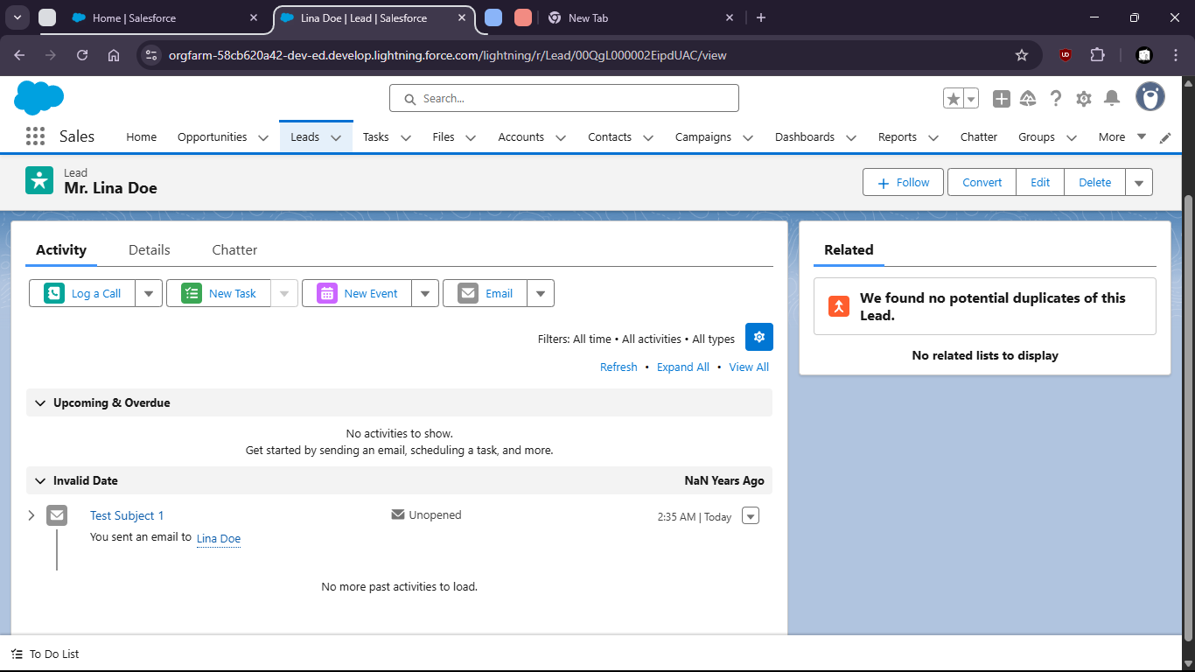

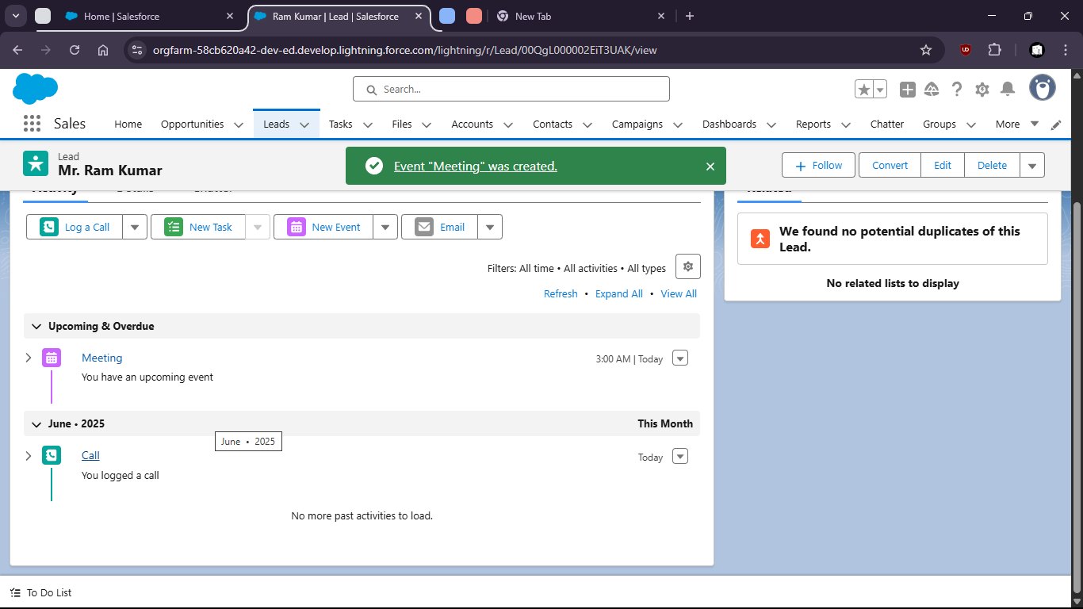

Task 4

Use App Launcher to navigate between Sales, Service, and Custom AppsSalses App

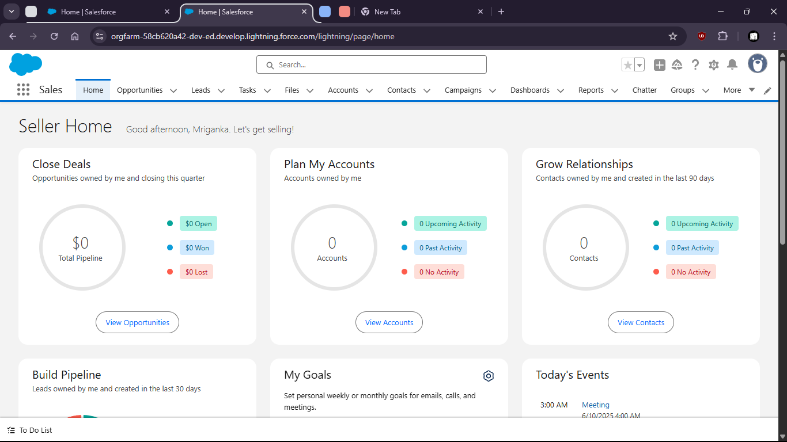

Service App

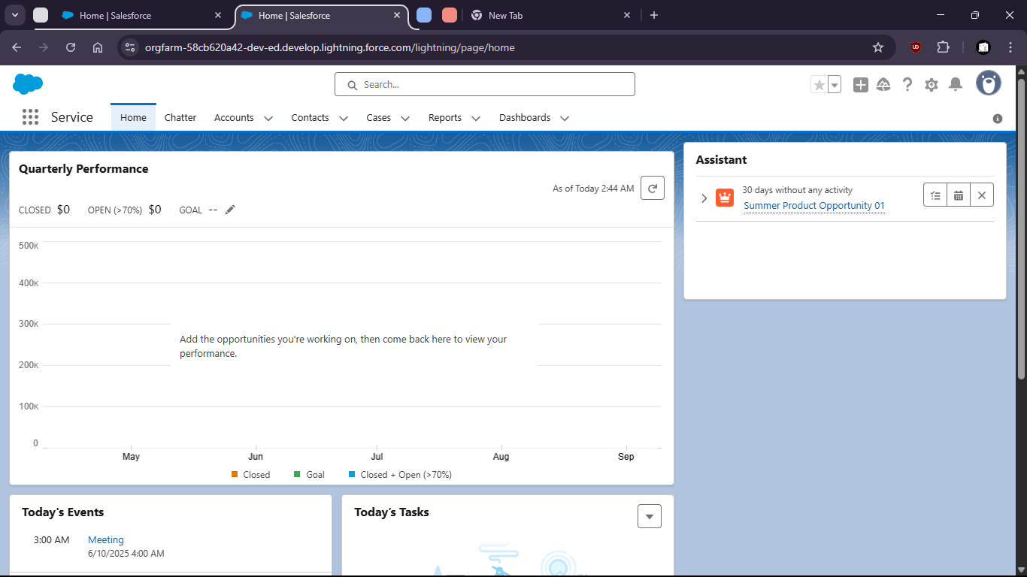

Custom Application : Sales Task (with custom object fields)

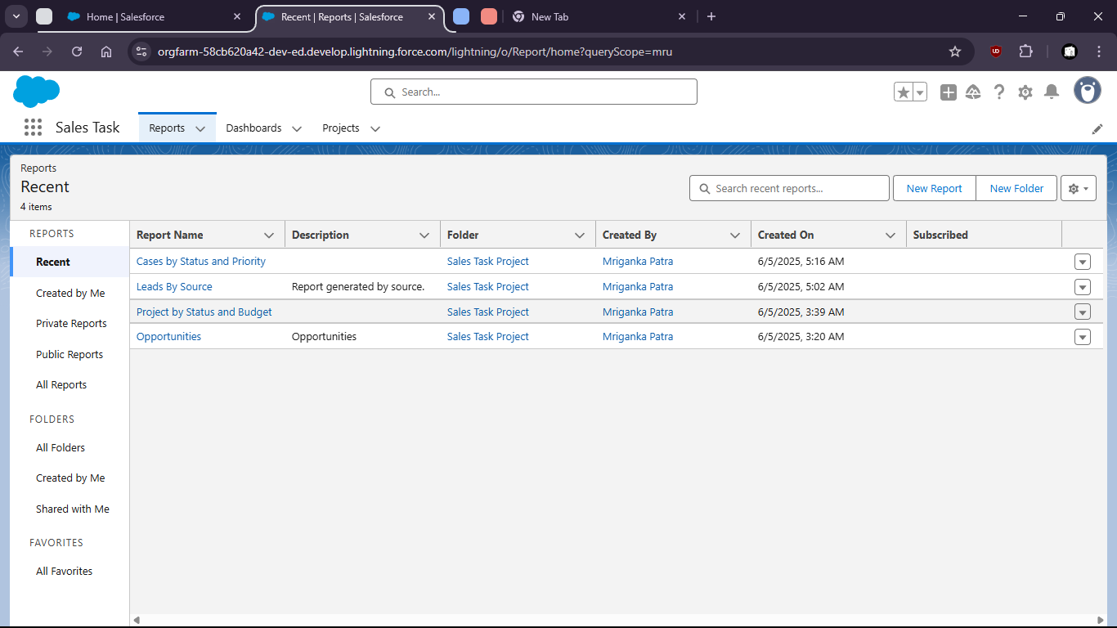

5: Visit App Exchange and install a free app (or document how to find and evaluate apps).

